**BÀI ÔN KHỐI 4 TỪ NGÀY 11 ĐẾN NGÀY 15 THÁNG 5**

1. **Find more words**

|  |  |  |  |
| --- | --- | --- | --- |
|  | **_ee_** | **_ea_** | **_y** |
| **Examples:** | **see** | t**ea** | jell**y** |
|  | ………….. | ………….. | ………….. |
|  | ………….. | ………….. | ………….. |
|  | ………….. | ………….. | ………….. |
|  | ………….. | ………….. | ………….. |
|  | ………….. | ………….. | ………….. |

1. **Choose five words from exercise I, make sentences.**

|  |  |  |
| --- | --- | --- |
| **Examples** | 1. see | *I can’t see anything.* |
|  | 1. ………… | ……………………………………………………….. |
|  | 1. ………… | ……………………………………………………….. |
|  | 1. ………… | ……………………………………………………….. |
|  | 1. ………… | ……………………………………………………….. |
|  | 1. ………… | ……………………………………………………….. |

1. **Look at the pictures and write.**

|  |  |
| --- | --- |
|  |  |
|  |  |
|  |  |
|  |  |

|  |  |
| --- | --- |
| 1. This place is hot and there are lots of different kinds of plants in it. | … a jungle... |
| 1. You can only see these at night. | ……………………. |
| 1. Farms have these. You see cows or sheep in them sometimes. | ……………………. |
| 1. This is a place that has a lot of houses, shops and people in it. | ……………………. |
| 1. Children who live in very cold places can play in this. | ……………………. |
| 1. These are often grey and give us rain. | ……………………. |
| 1. You can see these on most trees. | ……………………. |

1. **Look at the pictures and write the words.**

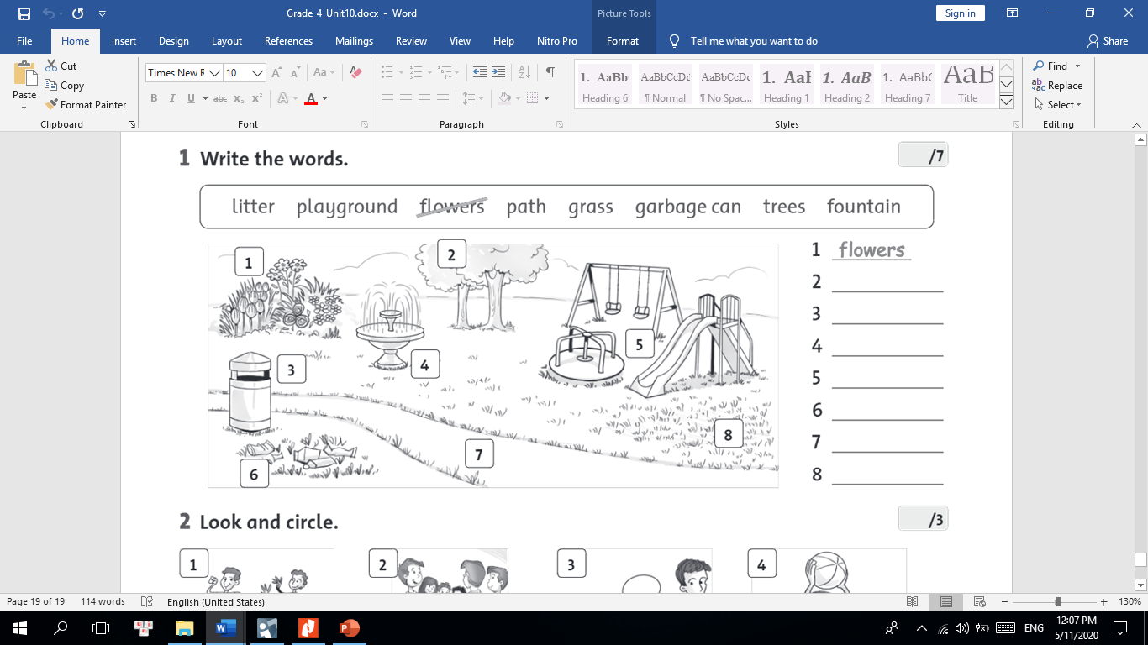

|  |  |
| --- | --- |
| 1. ………………………………… | 1. ………………………………… |
| 1. ………………………………… | 1. ………………………………… |
| 1. ………………………………… | 1. ………………………………… |
| 1. ………………………………… | 1. ………………………………… |

1. **Circle the correct words.**
2. You **must/mustn’t** be quiet in the library.
3. You **must/mustn’t** pick up flowers in the park.
4. You **must/mustn’t** make noise in class.
5. You **must/mustn’t** swim in a deep lake.
6. You **must/mustn’t** stand on the table in class.
7. You **must/mustn’t** use camera in the cinema.
8. You **must/mustn’t** keep your room tidy.
9. You **must/mustn’t** sing loudly in the library.
10. You **must/mustn’t** do your homework.
11. You **must/mustn’t** climb a tree at school.
12. **Listen and color**

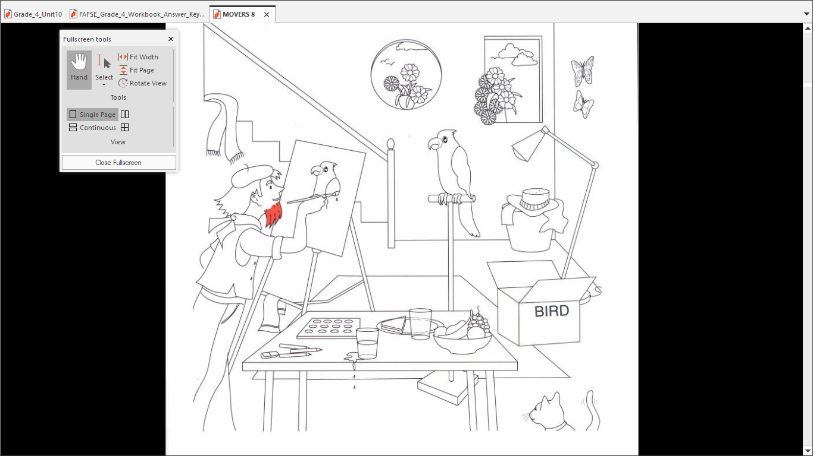

1. **Match sentences with the pictures.**

|  |  |  |
| --- | --- | --- |
|  | A. You mustn’t take photos here. | **2.** |
| **3.** | B. You must wash your hands.  C. You must put litter in the garbage can.  D. You mustn’t eat here.  E. You mustn’t walk your dog here. | **4.** |
|  | F. You must be quiet. |  |

|  |  |  |  |  |  |
| --- | --- | --- | --- | --- | --- |
| 1. **………..** | 1. **……….** | 1. **………** | 1. **………** | 1. **……..** | 1. **……** |

1. 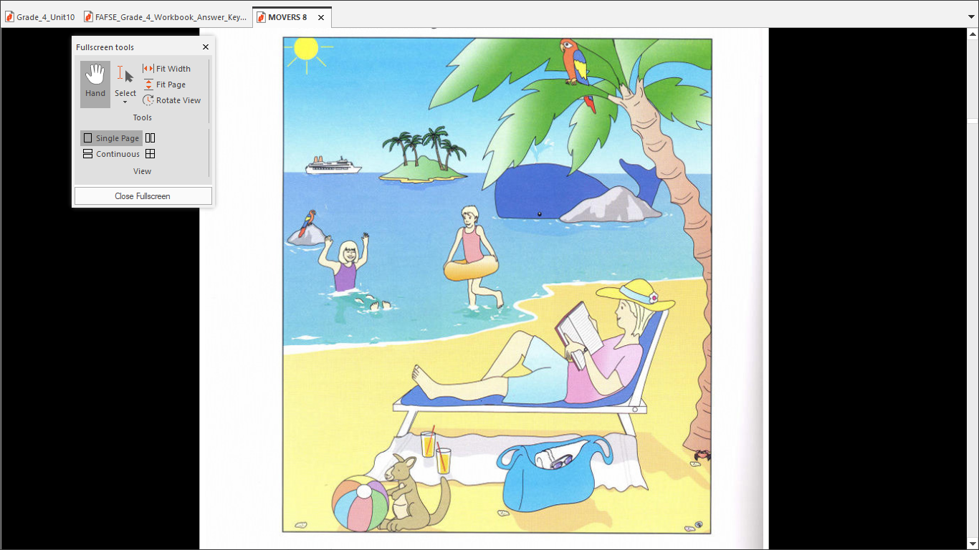**Look at pictures and write Yes or No.**

|  |  |
| --- | --- |
| *Examples:*  *A whale is behind the big rock in the sea.* | *………Yes………* |
| *There are five trees on the island.* | *………No…………* |
| 1. A parrot is flying above the boat. | *…………………….* |
| 1. A girl who has got long hair is running in the water. | *…………………….* |
| 1. There are two glasses of orange juice on the towel. | *…………………….* |
| 1. You can see a toy kangaroo between the bag and the ball. | *…………………….* |
| 1. The woman has a book in her hands and is wearing a watch. | *…………………….* |
| 1. The weather at the beach is cold, windy and wet. | *…………………….* |

* **The end -**